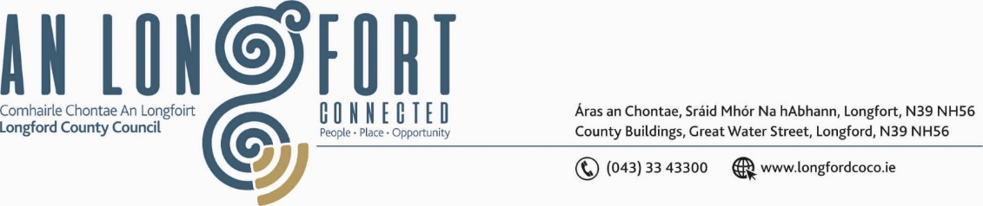

***BALLYMAHON MUNICIPAL DISTRICT***

***Please note meeting will be held in Ballymahon Library.***

**30 November 2022.**

**To: Each Member of Ballymahon Municipal District.**

**Dear Member,**

You are requested to attend a Meeting of Ballymahon Municipal District to be held

**in Ballymahon Library** on **Tuesday 6 December 2022 at 4pm** to transact business, as set out on the agenda hereunder.

**Yours sincerely**,

Ann Marie Mc Keon

_______________

**Ann Marie Mc Keon,**

**Meetings Administrator.**

**AGENDA**

Prayer before meeting.

**1.** Confirmation of Minutes:

(i) Ballymahon Municipal District Meeting held on the 22 September 2022 – copy enclosed.

(ii) Ballymahon Municipal District Committee Meeting held on the 22 September 2022 – copy enclosed.

(iii) Ballymahon Municipal District Meeting held on the 25 October 2022 – copy enclosed.

(iv) Ballymahon Municipal District Committee Meeting held on the 25 October 2022 – copy enclosed.

**2.** Matters arising from Minutes.

**3.** Declaration of Interest by Members.

**4.** Management Report - enclosed.

**5. Notices of Motions, submitted by Councillors, as listed hereunder –**

**Councillor Gerard Farrell**

1. That Longford County Council explain why they did not purchase the convent building and lands in Lanesboro as it seems no problem buying property in other towns within the county.
2. That Longford County Council take action to fix the drainage issue at O’Brien’s Corner Shop, Lanesboro.

**Councillor Paul Ross**

(i) That Longford County Council remove the traffic lights at Pound Street, Edgeworthstown in the interest of public safety.

1. I call on Longford County Council to implement traffic calming measures on the Bracklin Road, Edgeworthstown at the approach to St John’s National School.
2. I call on Longford County Council to install traffic calming measures on the N55 at St. Mary’s National School, warning drivers of the schools ahead as this is on a national primary route and has over 1,200 children daily using this section of road between those getting buses to secondary school and those attending primary school and the creche.

**Councillor Pat O’Toole**

I call on Longford County Council to assess the feasibility of putting a pedestrian/zebra crossing on the R392 (Main St., Ballymahon) from the Community Library across to SuperValu.